# **INFO7374 Algorithmic Digital Marketing**

## **Final Project**

|  |  |
| --- | --- |
| **Name** | **NEU ID** |
| Additya Dharangaonkar | 001052304 |
| Rohan Yewale | 001087414 |

# 

# **Best Buy**



Best Buy is a leading provider of technology products, services and solutions. The company offers expert service at an unbeatable price more than 1.5 billion times a year to the consumers, small business owners and educators who visit our stores, engage with Geek Squad agents or use BestBuy.com or the Best Buy app. The company has operations in the U.S and Canada, where more than 70 percent of the population lives within 15 minutes of a Best Buy store, as well as in Mexico where Best Buy has a physical and online presence.

# **Purpose**

The global consumer electronics e-commerce market is expected to grow from $282.6 billion in 2019 to about $373.6 billion in 2020 as the market initially experienced a surge due to purchase of electronic products that support work from home. The market is expected to stabilize and reach $548.4 billion at a CAGR of 18% through 2023.

Consumers are shifting from offline to online shopping, and this factor is the key driving factor of the consumer electronics e-commerce market.

# **Objectives**

* Identify the proposed trend in electronic sales
* Find Customer Lifetime Values and Churn Rates
* Use RFM analysis to segment the customers and run an effective promotional campaign for personalized service
* Predicting Next Purchase Date for a particular customer to improve Retention Rate
* Monthly Sales Forecasting
* Build dashboards around the KPIs to empower decision makers

# **Dataset**

Sales Dataset: Data from Online Retail E-Commerce Repository

* InvoiceNo
* StockCode
* Quantity
* InvoiceDate
* UnitPrice
* ShippingCost
* CustomerID
* State
* ProductID

Product Data: Best Buy Data (using Beautiful Soup)

* StockCode
* Product
* Img
* Type
* UnitPrice

# **Milestones**

|  |  |
| --- | --- |
| Timeframe | Delivery |
| Day 1-3 | Data Scrapping, Data Preprocessing and Explanatory Data Analysis |
| Day 4-8 | Model Building, Training, Selection |
| Day 9-10 | Deployment of models on cloud and build web application |
| Day 11-12 | System integration and Documentation |

# **Customer Segmentation using RFM analysis**

* Recency (R): Who have purchased recently? Number of days since last purchase
* Frequency (F): Who has purchased frequently? It means the total number of purchases
* Monetary Value(M): Who has a high purchase amount? It means the total money customer spent
* RFM (Recency, Frequency, Monetary) analysis is a behavior-based approach grouping customers into segments. It groups the customers based on their previous purchase transactions
* How recently, how often, and how much did a customer buy. RFM filters customers into various groups for the purpose of better service.
* It helps managers to run an effective promotional campaign for personalized service.

# **Next Purchase Date**

* By predicting the customer’s next purchase day, we can plan our promotion campaign for individual customers
* So, if a customer is nearing his next purchase date, we can send lucrative deals and promotion so that they will have a purchase on or before the predicted next purchase day
* Still if the purchase doesn’t occur after a significant time, the customer can be labelled inactive

# **Architecture**

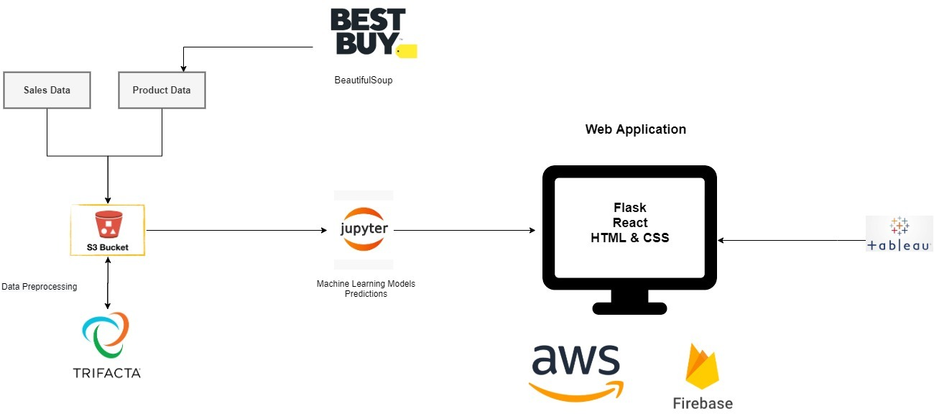

Storage

* S3 Bucket

Web Application:

* Frontend: HTML & CSS
* Backend: Flask

Deployment

* Cloud Platform: AWS (Amazon Web Services) EC2
* Web App: Firebase